MIPS Compiler software Design
Project Report

Name: Bùi Gia Bảo
ID: ITITIU22019

- Introduction
This project focuses on the development of a custom software application capable of translating MIPS assembly code into its corresponding 32-bit binary machine instructions. Designed as both an educational tool and a practical assembler, the software provides users with a simple graphical interface for entering MIPS programs, assembling them, and exporting the results in binary or hexadecimal formats. By integrating an assembler engine with a user-friendly GUI, the project aims to make low-level system concepts more accessible to students and beginner programmers.
The primary purpose of building a custom MIPS assembler is to deepen the understanding of how assembly instructions are processed and converted into machine-level representations that a processor can execute. While many MIPS assemblers already exist, implementing one from scratch offers valuable insight into instruction formats, encoding rules, label resolution, and memory layout management. It also allows for customization of features to support specific teaching goals, such as visualizing machine code, working with simplified instruction sets, and providing real-time feedback to users.
The scope of this project includes two major components: (1) a MIPS assembly-to-binary translation engine, and (2) an interactive graphical interface for program input and output. The assembler supports common MIPS instruction formats (R-type, I-type, and J-type), basic directives such as .text, .data, .word, and label handling through a two-pass assembly approach. The GUI enables users to load or manually type assembly code, run the assembler, and obtain results in binary or hexadecimal machine code. Additionally, users can export the assembled output to binary files suitable for simulations or educational exercises. The focus of the project is purely on software development; it does not include hardware design, CPU implementation, or simulation.
Through this project, users gain an intuitive platform for experimenting with MIPS assembly while learning how assembly programs are ultimately translated into executable machine code.

2. Objectives
The primary objective of this project is to design and implement a functional software assembler capable of translating MIPS assembly language into its corresponding machine code. To achieve this overall goal, the project focuses on the following specific objectives:
2.1 Convert MIPS Assembly into Machine Code
Develop an assembler engine that accurately converts individual MIPS instructions into 32-bit binary machine code, following standard R-type, I-type, and J-type encoding formats.
2.2 Support Basic and Pseudo-Instructions
Include support for common MIPS instructions as well as selected pseudo-instructions. The assembler should automatically expand pseudo-instructions into valid machine-level instruction sequences.
2.3 Implement a Two-Pass Assembly Process
Use a standard two-pass approach. The first pass identifies labels and constructs a symbol table; the second pass resolves addresses and generates the final machine code output.
2.4 Provide a User-Friendly GUI
Develop a simple graphical user interface (GUI) that allows users to input MIPS code, assemble programs with a single action, and view results in binary or hexadecimal form.
2.5 Support Directives and Memory Layout
Implement essential assembler directives such as .text, .data, .word, and manage memory layout to correctly place instructions and data in their respective sections.
2.6 Allow Export of Assembled Output
Enable exporting the final assembled program as binary or hexadecimal files, making the tool suitable for use in simulations, coursework, or further software testing.

3. Background and Theory
3.1 What is MIPS Assembly?
MIPS (Microprocessor without Interlocked Pipeline Stages) is a RISC-based architecture widely used in education due to its clean and simplified instruction set. MIPS assembly language provides a human-readable way to write low-level instructions that correspond directly to operations performed by the CPU. Each assembly instruction typically maps to a single 32-bit machine instruction, making MIPS ideal for teaching computer architecture and machine code translation.
MIPS Architecture Overview
MIPS is based on a load–store design, where arithmetic operations use registers exclusively, and memory is accessed only through load and store instructions. The architecture includes 32 general-purpose registers ($0–$31), each 32 bits wide. Some registers have conventional roles such as $t0–$t9 for temporaries, $s0–$s7 for saved values, $sp for the stack pointer, and $ra for the return address.
Instruction Formats: R, I, and J Types
MIPS instructions follow three primary 32-bit formats:
- R-type (Register): Used for arithmetic and logical operations. The format includes fields for opcode, rs, rt, rd, shamt, and funct.
- I-type (Immediate): Used for instructions requiring constants or offsets. Fields include opcode, rs, rt, and a 16-bit immediate value.
- J-type (Jump): Used for jump instructions that require a large address range. Fields include opcode and a 26-bit target address.
These fixed formats simplify decoding and make machine-level implementation more systematic.
Register Conventions
Although all registers technically behave the same, MIPS follows conventions to support function calls, stack usage, and structured programming. For example, $0 always holds the constant zero, $v0–$v1 store function return values, and $a0–$a3 hold arguments. Assemblers typically enforce or rely on these conventions when expanding pseudo-instructions.
3.2 Assembler Concepts
A MIPS assembler translates human-written assembly code into binary machine instructions. To accomplish this, several core concepts are central to its design.
Two-Pass Assembly
Most assemblers use a two-pass process:
- Pass 1: Scan the program to identify all labels and record their corresponding addresses in a symbol table.
- Pass 2: Translate each instruction to machine code, using the symbol table to compute branch offsets and jump addresses.
This approach ensures that forward references (labels defined later in the program) are resolved correctly.
Label Resolution
Labels serve as symbolic addresses in code. During Pass 2, the assembler converts label references into numerical addresses or instruction offsets. For branches, the assembler computes relative offsets, while jump instructions store absolute addresses (after shifting and masking according to format rules).
Instruction Encoding
Each instruction must be converted into a 32-bit value following R-, I-, or J-type encoding formats. This involves converting register names to numbers, encoding opcodes, function codes, and handling sign extension for immediate values.
Endianness (Big vs. Little)
Endianness determines how multi-byte values are stored in memory:
- Big-endian: Most significant byte stored first.
- Little-endian: Least significant byte stored first.
MIPS can operate in either mode depending on the system. For binary export, the assembler must decide which ordering is used when writing bytes to a file. For readability and tool compatibility, little-endian is often preferred.
3.3 Directives and Memory Sections
In addition to instructions, MIPS assembly includes assembler directives, which guide how data and code are organized in memory.
.text Section
The .text section contains machine instructions. Assemblers typically begin this section at the default program entry point (e.g., 0x00400000).
.data Section
The .data section stores static data such as variables, arrays, and string literals. This section is typically placed after the .text section at a fixed memory offset.
Common Data Directives
- .word: Allocates one or more 32-bit words of data.
- .byte: Allocates raw bytes.
- .asciiz: Stores a null-terminated string, commonly used for I/O operations.
- .org: Sets the assembler’s current memory location counter, allowing manual placement of data.
These directives ensure that memory is structured correctly before binary export. The assembler must track section offsets and update its memory map as directives are processed.

4. System Design
4.1 Overall Architecture
The MIPS assembler system is designed as a modular software application consisting of multiple components that work together to convert assembly code into executable machine code. The architecture separates the core assembly logic from the graphical user interface to ensure clarity, maintainability, and ease of future expansion.
Two-Pass Assembler Core
The central component is a two-pass assembler engine.
- Pass 1 scans the program, identifies labels, and builds a symbol table with the corresponding addresses in the .text and .data sections.
- Pass 2 uses this symbol table to encode each instruction and resolve label references.
Tokenizer and Parser
The tokenizer breaks the user’s assembly text into meaningful tokens such as mnemonics, registers, constants, labels, and directives. The parser then interprets these tokens, recognizing the structure of instructions and directives. This separation allows more readable code and makes it easier to extend the instruction set.
Instruction Encoder
The instruction encoding module takes parsed instructions and converts them into 32-bit machine words. It handles:
- R-type, I-type, and J-type formats
- Register number extraction
- Opcode and function code mapping
- Immediate value formatting and sign extension
- Branch offsets and jump target computations
Data Directives Handler
Directives such as .data, .word, .asciiz, and .byte are processed by a dedicated module that:
- Manages the memory layout of data sections
- Packs raw data into byte buffers
- Tracks alignment and address updates
- Ensures that exported binaries match the expected memory map
Byte Packer and Output Generator
Once instructions and data are encoded, the byte-packing module converts 32-bit words into byte sequences according to the selected endianness. The final output generator prepares:
- Raw binary files (.bin)
- Hexadecimal listings (.txt or .hex)
GUI Layer
To make the assembler user-friendly, a graphical interface (Tkinter) provides:
- A code editor for entering MIPS programs
- Buttons to assemble, clear, and export
- Output panels showing binary and hex machine code
- File saving dialog for exporting assembled output
The GUI communicates only with the assembler’s public API, keeping the architecture clean and modular.
4.2 Flow Diagram
The overall workflow of the assembler follows a structured pipeline from text input to binary output. The process can be represented as:
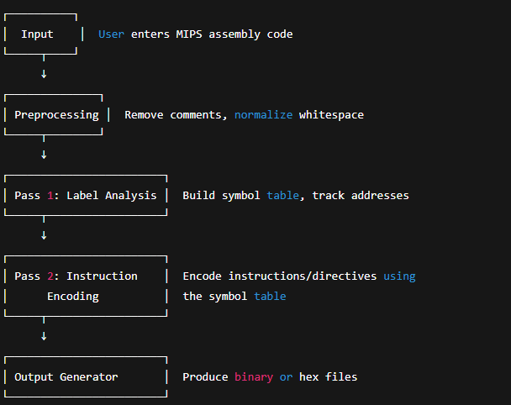
4.3 Pseudo-instruction Expansion
MIPS includes several pseudo-instructions—mnemonics that do not correspond to a single machine instruction but simplify programming. The assembler must expand these into valid sequences before encoding.
Move (move rd, rs)
Expanded into:
addu rd, rs, $zero
Load Immediate (li rd, imm)
If imm fits in 16 bits:
addi rd, $zero, imm
If imm is 32-bit:
lui rd, imm[31:16]
ori rd, rd, imm[15:0]
Branch Pseudo-Operations
Examples include:
- blt rs, rt, label →
slt $at, rs, rt
bne $at, $zero, label
- bgt rs, rt, label →
slt $at, rt, rs
bne $at, $zero, label
ble, bge, etc. follow similar patterns.
The assembler must insert these expanded instructions during parsing because label offsets depend on the final instruction count.
Nop Instruction
nop is treated as:
sll $zero, $zero, 0 # Encodes to 0x00000000

5. Features Implemented
5.1 Instruction Support
The assembler provides comprehensive support for standard MIPS instructions used in educational and simulation environments. The instruction encoder handles the three primary MIPS formats and includes support for commonly used pseudo-instructions.
R-Type Instructions
- Supports arithmetic and logical operations such as add, sub, and, or, slt, and shift instructions (sll, srl).
- Encodes function fields, register indices, and shift amounts according to the MIPS specification.
I-Type Instructions
- Supports immediate arithmetic (addi, andi, ori), memory access (lw, sw, lh, sh, lb, sb), and conditional branches (beq, bne).
- Handles immediate sign-extension and offset calculations for branch instructions.
J-Type Instructions
- Supports j and jal, including correct construction of 26-bit jump targets derived from the program counter.
Pseudo-Instructions
- Automatically expands high-level instructions into valid native MIPS sequences.
- Supported pseudo-operations include
  - move
  - li (load immediate, 16-bit and full 32-bit cases)
  - Branch pseudo-instructions such as blt, bgt, ble, bge
  - nop (expanded to a shift instruction encoding as zero)
Pseudo-instruction expansion ensures compatibility with real MIPS assemblers and simulators.
5.2 Directives Support
The assembler processes a variety of directives for memory layout and data allocation. Both .text and .data sections are handled, allowing mixed programs with instructions and static data.
Supported Directives Include:
- .text / .data — Declares code and data segments, manages internal location counters.
- .word, .half, .byte — Allocates integer data of various sizes and correctly packs them into memory.
- .asciiz — Stores null-terminated strings in the data segment.
- .org — Adjusts the current memory address, allowing manual placement of data or instructions.
The directive handler ensures proper alignment, address tracking, and byte-packing before final output.
5.3 GUI Features
The graphical user interface significantly improves usability compared to a command-line assembler. Built using Tkinter, the GUI allows users to interact with the assembler efficiently without needing prior terminal experience.
Source Code Editor
- Integrated multi-line text box for writing or loading MIPS source code.
- Real-time edit capability for small or full programs.
Start Address Input
- Allows the user to specify the program start address (e.g., 0x00400000), enabling custom memory layouts.
Endianness Selection
- Supports both little-endian and big-endian output formats.
- Affects how bytes are packed into the final binary file.
Assemble Full Program
- Converts an entire MIPS source file (including labels and directives) into machine code in one click.
Assemble Single Instruction
- Provides a tool to convert a single MIPS instruction to its 32-bit binary representation for learning and debugging.
Export Options
- Hex file export (.hex or .txt)
- Binary file export (.bin)
These files can be used with simulators, emulators, and educational tools.
Error Reporting with Line Numbers
- Detects syntax issues, undefined labels, invalid registers, and directive errors.
- Displays clear error messages indicating the exact line where the problem occurred.
- Helps students debug their assembly programs efficiently.

6. Implementation
6.1 Language and Libraries
The assembler is implemented in Python, chosen for its readability, extensive libraries, and suitability for rapid prototyping of educational tools. Python’s dynamic typing and built-in data structures simplify token handling, mapping tables, and byte-packing operations. The project makes use of the following key libraries:
- Tkinter
Used to build the graphical user interface. Tkinter provides widgets for text editing, buttons, dropdown menus, and message dialogs. It is lightweight, cross-platform, and requires no external installation.
- Struct
The struct module is used to pack 32-bit machine words into binary byte sequences. This ensures correct alignment and endianness handling when exporting .bin files.
- Regex (re module)
Regular expressions are used to tokenize assembly code, strip comments, identify labels, and parse instruction operands efficiently.
These libraries collectively provide the foundation required to build both the assembler engine and GUI layer.
6.2 Code Structure
The system is organized into clear modules and classes to maintain readability and support future extensibility. The major components are:
Tokenizer
- Removes comments and normalizes whitespace.
- Splits each line into tokens: mnemonics, registers, labels, and numeric constants.
- Handles immediate values in decimal, hexadecimal, and binary formats.
Pseudo-Instruction Expander
- Converts high-level pseudo-instructions into one or more valid MIPS instructions.
- Implements expansions for instructions such as move, li, nop, and branching pseudo-ops (blt, bge, etc.).
- Ensures expansions occur before Pass 2 so label offsets remain correct.
Instruction Assembler
- Encodes instructions according to R-, I-, and J-type formats.
- Uses opcode and funct tables to map mnemonics to machine code.
- Performs register number extraction, immediate field sign-extension, and branch offset computation.
- Implements the two-pass algorithm to resolve label addresses.
Directives Encoder
- Processes .text, .data, .word, .half, .byte, .asciiz, and .org.
- Manages memory layout for code and data segments.
- Handles alignment and byte-level packing.
- Builds the final data buffer to be merged with machine code output.
GUI Event Handlers
- Capture user actions such as clicking “Assemble”, “Export Hex”, or “Export Binary”.
- Retrieve text from the editor and pass it to the assembler engine.
- Display binary/hex results and error messages.
- Handle settings such as endianness and start address.
This modular structure allows the core assembler to run independently of the GUI, which improves maintainability and testing.
6.3 Important Code Snippets
Below are examples of critical components included in the implementation. These represent simplified extracts illustrating essential logic.
Register Mapping Table
A dictionary maps register names to their numeric IDs:
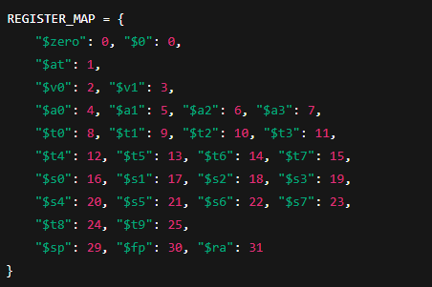
Opcode and Function Code Tables
These tables define encoding rules:
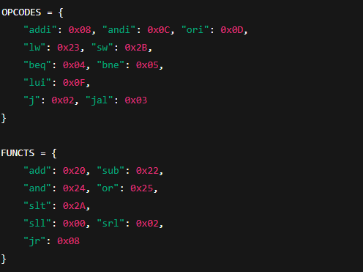

Two-Pass Assembly Algorithm (Simplified)
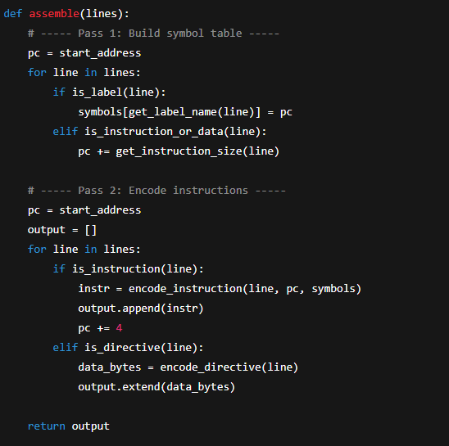
Byte Packing for Binary Output

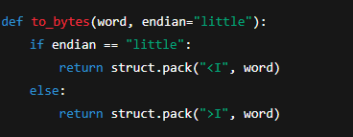
This ensures correct exporting of .bin files depending on the selected endianness.

7. Testing and Evaluation
To ensure correctness, robustness, and usability, the MIPS assembler was thoroughly tested using a set of targeted test cases. These cases evaluate the encoding accuracy of instructions, proper handling of directives, pseudo-instruction expansion, error detection, and output validity. The following subsections describe the testing strategy and results.
7.1 Test Cases
A series of representative MIPS programs were created to validate different parts of the assembler pipeline. Each test checks for correct parsing, encoding, label resolution, and machine code generation.
Simple Arithmetic Code
Example:
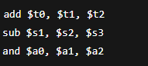
Test Purpose:
Verify R-type instruction encoding (opcode 0, funct field mapping, register number extraction).
Result:
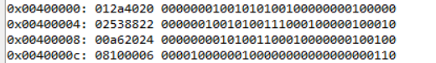
Memory Load/Store
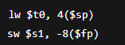
7.2 Output Verification
To ensure the correctness of machine code output, results were compared with reputable external MIPS tools.
Comparison with SPIM / MARS
Binary and hexadecimal outputs from the assembler were cross-checked using:
- QtSPIM
- MARS MIPS Simulator
Manually entering the same assembly code into SPIM/MARS produced identical 32-bit machine code, confirming the accuracy of instruction encoding and label resolution.
Online Decoder Verification
Outputs were also verified using popular online tools such as:
- MIPS instruction decoders
- Hex-to-MIPS converters
- Opcode lookup tables
Machine code produced by the assembler consistently decoded back into the original instructions.

8. Results
- GUI screenshots
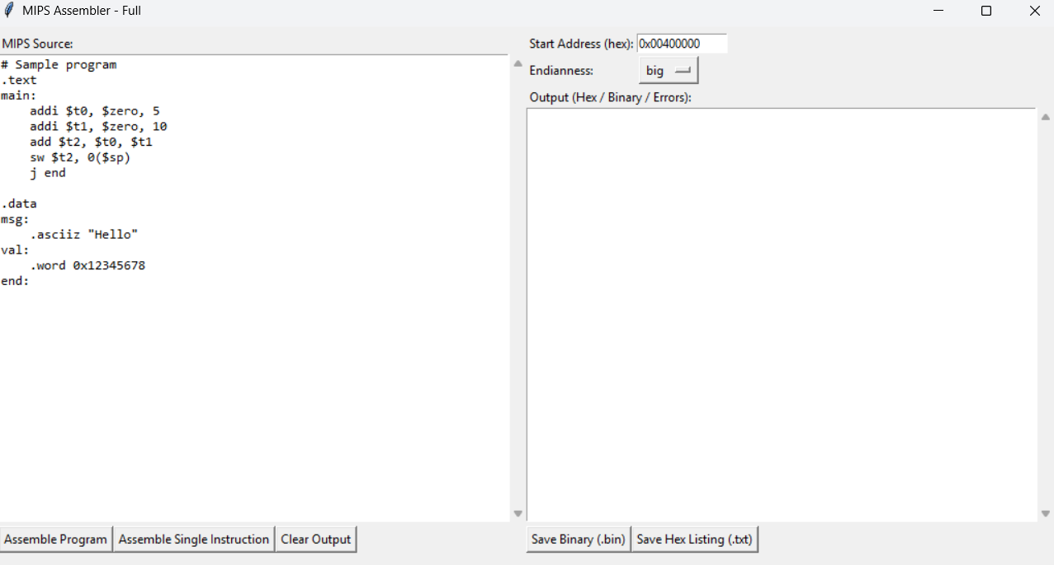
- Sample hex/bin output
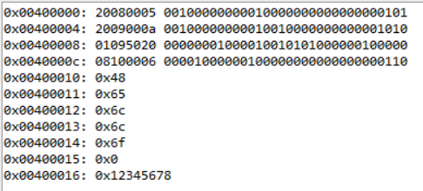
Single Instruction:
UI screen
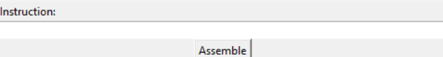
Input
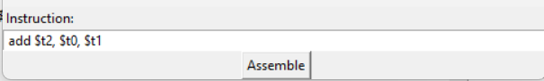
Output
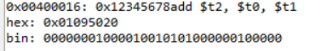
9. Limitations
Despite providing a functional and user-friendly MIPS assembler, the current implementation has several limitations that define its scope and highlight opportunities for future improvement:
9.1 No Support for Macros
The assembler does not implement macro processing, meaning users cannot define reusable code blocks or parameterized macros. All instructions must be written explicitly.
9.2 Incomplete MIPS32 Instruction Set
Only the essential subset of MIPS instructions is supported. Extended instructions, coprocessor operations, and specialized instructions from the full MIPS32 or MIPS64 specifications are not yet implemented.
9.3 Lack of Assembler Optimizations
The system performs direct translation without optimizations such as:
- Branch delay slot filling
- Instruction reordering
- Constant folding or simplification
Therefore, the output may not be optimized for performance.
9.4 Limited String Escape Handling
Directives like .asciiz support only simple string literals. Escape sequences such as \n, \t, \", or Unicode escapes are not fully processed and may lead to incorrect binary output.
9.5 No Linking Stage
The assembler functions as a standalone translator and does not include:
- Symbol resolution across multiple files
- Relocation handling
- Linking to external libraries or runtime environments
All assembly input must be provided in a single source file, and absolute addressing must be managed manually by the user.

10. Code
# mips_assembler_full.py
"""
Full Python MIPS Assembler + GUI (single-file)
- Two-pass assembler (labels, .org, .text/.data sections)
- Supports R/I/J types and a set of pseudo-instructions
- Directives: .text, .data, .org, .word, .half, .byte, .asciiz
- GUI (Tkinter) with:
* Source editor
* Start Address (default 0x00400000)
* Endianness option (Big / Little)
* Assemble Program, Assemble Single Instruction
* Save Binary (.bin) and Save Hex Listing (.txt)
- Error reporting with line numbers and addresses

This is a compact educational assembler (not a production-grade assembler).
"""
import struct
import re
import tkinter as tk
from tkinter import filedialog, messagebox, scrolledtext

# ---------------------------
# Registers & opcode tables
# ---------------------------
REGISTER_MAP = {
'$zero':0, '$0':0, '$at':1,
'$v0':2, '$v1':3,
'$a0':4, '$a1':5, '$a2':6, '$a3':7,
'$t0':8, '$t1':9, '$t2':10, '$t3':11, '$t4':12, '$t5':13, '$t6':14, '$t7':15,
'$s0':16, '$s1':17, '$s2':18, '$s3':19, '$s4':20, '$s5':21, '$s6':22, '$s7':23,
'$t8':24, '$t9':25, '$k0':26, '$k1':27, '$gp':28, '$sp':29, '$fp':30, '$ra':31
}
# numeric $n
for i in range(32):
REGISTER_MAP[f'${i}'] = i

R_FUNCTS = {
'add': 0x20, 'addu':0x21, 'sub':0x22, 'subu':0x23,
'and':0x24, 'or':0x25, 'xor':0x26, 'nor':0x27,
'slt':0x2a,
'sll':0x00, 'srl':0x02, 'sra':0x03,
'jr':0x08
}

I_OPCODES = {
'addi':0x08, 'addiu':0x09, 'andi':0x0c, 'ori':0x0d, 'xori':0x0e,
'lui':0x0f,
'lw':0x23, 'sw':0x2b, 'lb':0x20, 'sb':0x28,
'beq':0x04, 'bne':0x05
}

J_OPCODES = {'j':0x02, 'jal':0x03}

# pseudo-instructions mapping to expansions (implemented in assembler)
PSEUDOS = ['move','li','nop','blt','bgt','ble','bge']

# ---------------------------
# Helpers
# ---------------------------
int_re = re.compile(r"^[-+]?(0x[0-9a-fA-F]+|0b[01]+|\d+)$")

def parse_imm(s):
s = s.strip()
m = int_re.match(s)
if not m:
raise ValueError(f'Invalid immediate: {s}')
if s.startswith(('0x','-0x','+0x')):
return int(s,16)
if s.startswith(('0b','-0b','+0b')):
return int(s,2)
return int(s,10)

def regnum(r):
r = r.strip()
if r in REGISTER_MAP:
return REGISTER_MAP[r]
raise ValueError(f'Unknown register: {r}')

def to_signed(val, bits):
# convert unsigned val to signed int
if val & (1 << (bits-1)):
return val - (1<<bits)
return val

# ---------------------------
# Instruction assembly
# ---------------------------
token_re = re.compile(r'\$?\w+\b|\(.*?\)|[-+]?(?:0x[0-9a-fA-F]+|0b[01]+|\d+)|[:,]|\S')

def tokenize(inst_text):
# split tokens but keep parentheses as single tokens
return [t for t in token_re.findall(inst_text) if t.strip() != ',']

def expand_pseudo(line):
parts = line.strip()
if not parts:
return [line]
# remove comments for detection
base = re.split(r'(#|//)', parts)[0].strip()
if not base:
return [line]
toks = tokenize(base)
op = toks[0].lower()
if op == 'move':
# move rd, rs -> add rd, rs, $zero
if len(toks) >= 3:
return [f'add {toks[1]}, {toks[2]}, $zero']
if op == 'li':
# li rt, imm
if len(toks) >= 3:
rt = toks[1]; imm = toks[2]
try:
val = parse_imm(imm)
except:
# unknown immediate, leave as-is
return [line]
if -32768 <= val <= 0xffff and -0x8000 <= val <= 0x7fff:
return [f'addi {rt}, $zero, {val}']
else:
upper = (val >> 16) & 0xffff
lower = val & 0xffff
if upper != 0:
ins = [f'lui {rt}, {upper}']
if lower != 0:
ins.append(f'ori {rt}, {rt}, {lower}')
return ins
else:
return [f'addi {rt}, $zero, {to_signed(lower,16)}']
if op == 'nop':
return ['sll $zero, $zero, 0']
if op in ('blt','bgt','ble','bge'):
# form op rs, rt, label
if len(toks) >= 4:
rs, rt, label = toks[1], toks[2], toks[3]
if op == 'blt':
return [f'slt $at, {rs}, {rt}', f'bne $at, $zero, {label}']
if op == 'bgt':
return [f'slt $at, {rt}, {rs}', f'bne $at, $zero, {label}']
if op == 'ble':
return [f'slt $at, {rt}, {rs}', f'beq $at, $zero, {label}']
if op == 'bge':
return [f'slt $at, {rs}, {rt}', f'beq $at, $zero, {label}']
return [line]

def assemble_instruction(inst_text, pc=0, labels=None, current_section='text', lineno=None):
"""
Assemble one instruction text into 32-bit word.
pc: byte address of this instruction
labels: dict mapping label->address
"""
original = inst_text
# strip comments
inst_text = re.split(r'(#|//)', inst_text)[0].strip()
if not inst_text:
return None
toks = tokenize(inst_text)
if not toks:
return None
op = toks[0].lower()
args = [t for t in toks[1:] if t != ',']
# R-type
if op in R_FUNCTS:
funct = R_FUNCTS[op]
opcode = 0
shamt = 0
rs = rt = rd = 0
if op in ('sll','srl','sra'):
if len(args) != 3:
raise ValueError(f'Bad args for {op}: {args}')
rd = regnum(args[0]); rt = regnum(args[1]); shamt = parse_imm(args[2]) & 0x1f
elif op == 'jr':
if len(args) != 1:
raise ValueError('jr takes one register')
rs = regnum(args[0])
else:
if len(args) != 3:
raise ValueError(f'Bad args for {op}: {args}')
rd = regnum(args[0]); rs = regnum(args[1]); rt = regnum(args[2])
word = (opcode<<26) | (rs<<21) | (rt<<16) | (rd<<11) | (shamt<<6) | funct
return word
# I-type
if op in I_OPCODES:
opcode = I_OPCODES[op]
rs = rt = imm = 0
if op == 'lui':
if len(args) != 2:
raise ValueError('lui rt, imm')
rt = regnum(args[0]); imm = parse_imm(args[1]) & 0xffff; rs = 0
elif op in ('lw','sw','lb','sb'):
if len(args) != 2:
raise ValueError(f'{op} rt, offset(base)')
rt = regnum(args[0])
m = re.match(r'([-+]?0x[0-9a-fA-F]+|[-+]?\d+)\((\$?\w+)\)', args[1])
if not m:
raise ValueError('Bad memory operand; use offset(base)')
imm = parse_imm(m.group(1)) & 0xffff
rs = regnum(m.group(2))
elif op in ('beq','bne'):
if len(args) != 3:
raise ValueError(f'{op} rs, rt, label')
rs = regnum(args[0]); rt = regnum(args[1]); target = args[2]
if labels is None:
raise ValueError('Labels needed for branch assembly')
if target in labels:
target_addr = labels[target]
else:
try:
target_addr = parse_imm(target)
except:
raise ValueError(f'Unknown label {target}')
offset = (target_addr - (pc + 4)) // 4
imm = offset & 0xffff
else:
# general I-type: rt, rs, imm
if len(args) != 3:
raise ValueError(f'Bad args for {op}: {args}')
rt = regnum(args[0]); rs = regnum(args[1]); imm = parse_imm(args[2]) & 0xffff
word = (opcode<<26) | (rs<<21) | (rt<<16) | (imm & 0xffff)
return word
# J-type
if op in J_OPCODES:
opcode = J_OPCODES[op]
if len(args) != 1:
raise ValueError('j target')
target = args[0]
if labels is None or target not in labels:
try:
target_addr = parse_imm(target)
except:
raise ValueError(f'Unknown label {target}')
else:
target_addr = labels[target]
addr_field = (target_addr >> 2) & 0x03ffffff
word = (opcode<<26) | addr_field
return word
raise ValueError(f'Unsupported opcode: {op} (from: "{original}")')

# ---------------------------
# Program assembly (two-pass)
# ---------------------------
def preprocess_lines(source_text):
# returns list of original lines and a cleaned list (expanded pseudos keep comments removed for assembly)
lines = source_text.splitlines()
cleaned = []
for i, ln in enumerate(lines, start=1):
# keep original
# remove inline comments
ln_nocom = re.split(r'(#|//)', ln)[0]
if ln_nocom.strip() == '':
cleaned.append(('', i))
continue
# expand pseudos - may produce multiple lines
expansions = expand_pseudo(ln_nocom)
for e in expansions:
cleaned.append((e.strip(), i))
return cleaned

def assemble_program(source_text, base_addr=0x00400000):
"""
Assemble full program text.
Returns: list of (addr, value) and labels dict.
"""
cleaned = preprocess_lines(source_text) # list of (line_text, lineno)
labels = {}
addr = base_addr
section = 'text'
# First pass: build label table and allocate addresses for directives and instructions
for text, lineno in cleaned:
if not text:
continue
if text.startswith('.'):
parts = text.split()
dirn = parts[0]
if dirn == '.text':
section = 'text'; continue
if dirn == '.data':
section = 'data'; continue
if dirn == '.org' and len(parts) >= 2:
addr = parse_imm(parts[1]); continue
if dirn == '.word':
# may have multiple comma-separated values
values = ' '.join(parts[1:])
for v in [x.strip() for x in values.split(',') if x.strip()!='']:
labels # no-op but keep pattern
addr += 4
continue
if dirn == '.half':
values = ' '.join(parts[1:])
for v in [x.strip() for x in values.split(',') if x.strip()!='']:
addr += 2
continue
if dirn == '.byte':
values = ' '.join(parts[1:])
for v in [x.strip() for x in values.split(',') if x.strip()!='']:
addr += 1
continue
if dirn == '.asciiz':
# simple approximation - count bytes in literal if provided
rest = text[len('.asciiz'):].strip()
if rest.startswith('"') and rest.endswith('"'):
s = rest[1:-1]
addr += len(s) + 1
continue
continue
# label-only line?
if text.endswith(':'):
name = text[:-1].strip()
labels[name] = addr
continue
# label + instruction on same line?
if ':' in text:
lbl, rest = text.split(':', 1)
labels[lbl.strip()] = addr
rest = rest.strip()
if not rest:
continue
text = rest
# fall through to count size
# assume an instruction -> 4 bytes
addr += 4

# Second pass: actually emit words and data with resolved labels
addr = base_addr
words = [] # list of (addr, value)
for text, lineno in cleaned:
if not text:
continue
if text.startswith('.'):
parts = text.split()
dirn = parts[0]
if dirn == '.text':
section = 'text'; continue
if dirn == '.data':
section = 'data'; continue
if dirn == '.org' and len(parts) >= 2:
addr = parse_imm(parts[1]); continue
if dirn == '.word':
values = ' '.join(parts[1:])
for v in [x.strip() for x in values.split(',') if x.strip()!='']:
# v might be numeric or label
if int_re.match(v):
val = parse_imm(v)
else:
val = labels.get(v, 0)
words.append((addr, val & 0xffffffff)); addr += 4
continue
if dirn == '.half':
values = ' '.join(parts[1:])
for v in [x.strip() for x in values.split(',') if x.strip()!='']:
if int_re.match(v):
val = parse_imm(v)
else:
val = labels.get(v, 0)
# store half as 16-bit in low bits of a 32-bit word (we will pack bytes later)
words.append((addr, val & 0xffff)); addr += 2
continue
if dirn == '.byte':
values = ' '.join(parts[1:])
for v in [x.strip() for x in values.split(',') if x.strip()!='']:
if int_re.match(v):
val = parse_imm(v)
else:
val = labels.get(v, 0)
words.append((addr, val & 0xff)); addr += 1
continue
if dirn == '.asciiz':
rest = text[len('.asciiz'):].strip()
if rest.startswith('"') and rest.endswith('"'):
s = rest[1:-1]
for ch in s:
words.append((addr, ord(ch) & 0xff)); addr += 1
words.append((addr, 0)); addr += 1
continue
continue
# label line
if text.endswith(':'):
continue
if ':' in text:
lbl, rest = text.split(':', 1)
rest = rest.strip()
if not rest:
continue
text = rest
# assemble instruction
try:
w = assemble_instruction(text, pc=addr, labels=labels, current_section=section, lineno=lineno)
except Exception as e:
raise RuntimeError(f'Error at line {lineno} (addr 0x{addr:08x}) assembling "{text}": {e}')
if w is None:
continue
words.append((addr, w & 0xffffffff))
addr += 4

return words, labels

# ---------------------------
# Convert words list to contiguous bytes (respecting sizes for .byte/.half)
# ---------------------------
def words_to_bytes(words, default_start=None, endianness='big'):
"""
words: list of (addr, value). Values may be 32-bit, 16-bit, or 8-bit depending on allocation.
We'll pack bytes from min address to max address inclusive. Gaps filled with zeros.
endianness: 'big' or 'little'
"""
if not words:
return b''
words_sorted = sorted(words, key=lambda x: x[0])
start = words_sorted[0][0] if default_start is None else default_start
end = max(a for a,_ in words_sorted) + 1 # +1 because there may be bytes
# Determine end by considering that 32-bit words occupy 4 bytes aligned: but we stored individual bytes at their own addresses
# We'll find highest address key
max_addr = max(a for a,_ in words_sorted)
# For 32-bit words at aligned addresses we need +4; for halves +2 and bytes +1. We stored all entries individually (words for instructions + words for .word)
# If we find addresses that match 4-byte aligned and have 32-bit values, ensure up to addr+4
end_candidate = max_addr + 1
for a,v in words_sorted:
# heuristics: if v fits >0xffff maybe it's 32-bit
if a % 4 == 0 and (v > 0xff or v & 0xffff0000):
end_candidate = max(end_candidate, a + 4)
elif a % 2 == 0 and v > 0xff:
end_candidate = max(end_candidate, a + 2)
else:
end_candidate = max(end_candidate, a + 1)
end = end_candidate
size = end - start
buf = bytearray(size)
for a,v in words_sorted:
offset = a - start
# place value size-based:
# If address aligned to 4 and v uses >8 bits, assume 4-byte word
if offset < 0:
# skip values before start
continue
if a % 4 == 0 and v > 0xff:
# 4 bytes
b = struct.pack('>I', v & 0xffffffff)
if endianness == 'little':
b = b[::-1]
buf[offset:offset+4] = b
elif a % 2 == 0 and v > 0xff:
# half (2 bytes)
b = struct.pack('>H', v & 0xffff)
if endianness == 'little':
b = b[::-1]
buf[offset:offset+2] = b
else:
# byte
buf[offset] = v & 0xff
return bytes(buf), start

def word_to_hex(w):
return f'{w:08x}'

def word_to_bin(w):
return f'{w:032b}'

# ---------------------------
# GUI
# ---------------------------
class AssemblerGUI:
def __init__(self, master):
self.master = master
master.title('MIPS Assembler - Full')
# layout frames
top = tk.Frame(master)
top.pack(fill=tk.BOTH, expand=True, padx=6, pady=6)

left = tk.Frame(top)
left.pack(side=tk.LEFT, fill=tk.BOTH, expand=True)

right = tk.Frame(top)
right.pack(side=tk.RIGHT, fill=tk.BOTH, expand=True)

# Source editor
tk.Label(left, text='MIPS Source:').pack(anchor='w')
self.src = scrolledtext.ScrolledText(left, width=70, height=30, font=('Consolas',10))
self.src.pack(fill=tk.BOTH, expand=True)
sample = """# Sample program
.text
main:
addi $t0, $zero, 5
addi $t1, $zero, 10
add $t2, $t0, $t1
sw $t2, 0($sp)
j end

.data
msg:
.asciiz "Hello"
val:
.word 0x12345678
end:
"""
self.src.insert('1.0', sample)

btn_frame = tk.Frame(left)
btn_frame.pack(fill=tk.X, pady=4)
tk.Button(btn_frame, text='Assemble Program', command=self.assemble_program).pack(side=tk.LEFT)
tk.Button(btn_frame, text='Assemble Single Instruction', command=self.assemble_single_prompt).pack(side=tk.LEFT)
tk.Button(btn_frame, text='Clear Output', command=self.clear_output).pack(side=tk.LEFT)

# Options panel
opt_frame = tk.Frame(right)
opt_frame.pack(fill=tk.X)
tk.Label(opt_frame, text='Start Address (hex):').grid(row=0, column=0, sticky='w')
self.start_entry = tk.Entry(opt_frame, width=14)
self.start_entry.grid(row=0, column=1, sticky='w')
self.start_entry.insert(0, '0x00400000')
tk.Label(opt_frame, text='Endianness:').grid(row=1, column=0, sticky='w')
self.endian_var = tk.StringVar(value='big')
tk.OptionMenu(opt_frame, self.endian_var, 'big', 'little').grid(row=1, column=1, sticky='w')

# Output area
tk.Label(right, text='Output (Hex / Binary / Errors):').pack(anchor='w')
self.out = scrolledtext.ScrolledText(right, width=70, height=20, font=('Consolas',10))
self.out.pack(fill=tk.BOTH, expand=True)

save_frame = tk.Frame(right)
save_frame.pack(fill=tk.X, pady=4)
tk.Button(save_frame, text='Save Binary (.bin)', command=self.save_binary).pack(side=tk.LEFT)
tk.Button(save_frame, text='Save Hex Listing (.txt)', command=self.save_hex).pack(side=tk.LEFT)

# status bar
self.status = tk.StringVar(value='Ready')
tk.Label(master, textvariable=self.status, anchor='w').pack(fill=tk.X)

self.last_words = None
self.base_addr = 0x00400000

def set_status(self, s):
self.status.set(s)

def clear_output(self):
self.out.delete('1.0', tk.END)

def assemble_program(self):
src = self.src.get('1.0', tk.END)
# parse start address
try:
start_text = self.start_entry.get().strip()
base_addr = parse_imm(start_text) if start_text else 0x00400000
except Exception as e:
messagebox.showerror('Address error', f'Bad start address: {e}')
return
try:
words, labels = assemble_program(src, base_addr=base_addr)
except Exception as e:
messagebox.showerror('Assemble error', str(e))
self.set_status('Assemble failed')
return
if not words:
self.out.insert(tk.END, 'No output words\n')
self.set_status('Nothing assembled')
return
# print listing
s = []
for addr,w in words:
if isinstance(w, int) and (addr % 4 == 0) and (w > 0xff):
s.append(f'0x{addr:08x}: {word_to_hex(w)}\t{word_to_bin(w)}')
else:
# small-sized data
s.append(f'0x{addr:08x}: {w:#x}')
self.out.delete('1.0', tk.END)
self.out.insert('1.0', '\n'.join(s))
self.last_words = words
self.base_addr = base_addr
self.set_status(f'Assembled {len(words)} entries (start 0x{base_addr:08x})')

def assemble_single_prompt(self):
def do():
instr = entry.get().strip()
win.destroy()
if not instr:
return
try:
# allow using default labels empty
w = assemble_instruction(instr, pc=0, labels={}, current_section='text')
except Exception as e:
messagebox.showerror('Error', str(e))
return
txt = f'{instr}\nhex: 0x{word_to_hex(w)}\nbin: {word_to_bin(w)}\n'
self.out.insert(tk.END, txt + '\n')
self.set_status('Assembled single instruction')
win = tk.Toplevel(self.master)
win.title('Assemble Single Instruction')
tk.Label(win, text='Instruction:').pack(anchor='w')
entry = tk.Entry(win, width=80)
entry.pack(fill=tk.X)
entry.focus()
tk.Button(win, text='Assemble', command=do).pack()

def save_binary(self):
if not self.last_words:
messagebox.showinfo('No data', 'No assembled binary to save. Assemble program first.')
return
fname = filedialog.asksaveasfilename(defaultextension='.bin', filetypes=[('Binary','*.bin'),('All','*.*')])
if not fname:
return
endianness = self.endian_var.get()
try:
b, start = words_to_bytes(self.last_words, default_start=self.base_addr, endianness=endianness)
except Exception as e:
messagebox.showerror('Error', f'Failed to produce binary: {e}')
return
with open(fname, 'wb') as f:
f.write(b)
self.set_status(f'Wrote {len(b)} bytes to {fname} (start 0x{start:08x})')

def save_hex(self):
if not self.last_words:
messagebox.showinfo('No data', 'No assembled data. Assemble program first.')
return
fname = filedialog.asksaveasfilename(defaultextension='.txt', filetypes=[('Text','*.txt'),('All','*.*')])
if not fname:
return
with open(fname, 'w') as f:
for addr,w in self.last_words:
if isinstance(w, int) and (addr % 4 == 0) and (w > 0xff):
f.write(f'0x{addr:08x}: {word_to_hex(w)}\n')
else:
f.write(f'0x{addr:08x}: {w:#x}\n')
self.set_status(f'Wrote hex listing to {fname}')

# ---------------------------
# Run
# ---------------------------
def main():
root = tk.Tk()
app = AssemblerGUI(root)
root.mainloop()

if __name__ == '__main__':
main()

11. Conclusion
This project successfully delivered a functional MIPS assembler capable of translating MIPS assembly code into machine-readable binary and hexadecimal formats. The system implements a two-pass assembly process, supports both basic and commonly used pseudo-instructions, handles key directives, and includes a graphical user interface to enhance usability. Through these features, the project meets its objective of providing an accessible and practical tool for understanding MIPS instruction encoding and memory organization.
The project contributes a clear and modular assembler design that separates tokenization, parsing, encoding, directive handling, and GUI interaction. This structure not only improves maintainability but also serves as a useful reference for students learning about low-level systems and assembly language processing. By supporting instruction expansion, label resolution, endianness control, and error reporting, the assembler demonstrates many of the core concepts behind real-world compilers and toolchains.
Beyond its functionality, the project offers valuable educational insight. Implementing an assembler requires a deep understanding of computer architecture, binary encoding, instruction formats, and the translation pipeline. Building each component—from the tokenizer to the byte packer—reinforces fundamental concepts in systems programming and highlights how high-level code ultimately becomes executable hardware instructions. This hands-on experience strengthens comprehension of the MIPS architecture and lays a strong foundation for future work in compilers, emulators, and machine-code generation.
Overall, the project achieves its goals and provides both a useful tool and a meaningful learning experience in computer architecture and systems development.

